

|  |
| --- |
| BLACKSMITH |
| Business Proposal |
| October 2011 |

Table of Contents

Executive Summary3

General Company Description5

Products and Services7

Marketing13

Competitive Analysis20

Financial Plan23

### Executive Summary

Coffee and coffee shops have been staples of the American community for nearly a century. More than simply a cup of brewed beans, coffee shops now offer a variety of memorable experiences for patrons ⎯ an inexpensive, flavorful escape from daily stresses, a chance to sit and have relaxing discussions amongst friends or the opportunity to enjoy the pleasures and subtle nuances of coffee varieties with an experienced barista. Houstonians have embraced the newly found growth of craft coffee production; however they have limited well-executed locations in which to enjoy these experiences. With Houstonians going out for food and beverages more than residents of any other city, there becomes an opportunity to create a coffee destination built around high quality coffee products, aesthetically pleasing atmosphere, and an experienced, progressive management team. Add to this an ownership of diverse and dedicated local minds and you have the ingredients for a successful craft coffee business ⎯ Blacksmith.

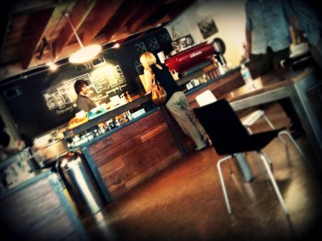The brains behind Blacksmith, David Buehrer and Ecky Prabanto, have guided the highly acclaimed and successful Greenway Coffee Company (GCC) for 5 years within the subterranean location within Greenway Plaza. David and Ecky’s dedication, knowledge and passion to the coffee industry, and to Greenway Coffee Company, paved the way for unheralded local and national recognition. Greenway is consistently named one of, if not the best, coffee offerings in Houston, and is well-respected nationally. Additionally, GCC launched their own roasting company in May of 2011 to vertically integrate into their coffee companies. There is now an opportunity to move beyond the basement of the Greenway Plaza complex in order to showcase the highest quality coffee product, coffee variety and expertly trained service staff within an established location universally known and easily accessible to Houstonians.

In addition to Buehrer and Prabanto’s experience and business success, Blacksmith will be a partnership with 1018 Real Estate Group (1018 REG), the individuals behind the upcoming Underbelly and The Hay Merchant destinations, as well as the owners of the building in which Blacksmith will be located. 1018 REG includes Robert Heugel, Kevin Floyd, Steve Flippo, Michael Burnett and Chris Shepherd. 1018 REG’s experience will be instrumental in the build-out, permitting, administrative management, marketing and other operational elements. This dynamic partnership is designed for the overall benefit of these projects and will prove to have long-lasting impacts that would not be available in a traditional tenant-landlord relationship.

The following proposal will illustrate the strong business opportunity a craft coffee location can offer to savvy investors. To execute this business plan, the partnership group is seeking $400,000 in private investment. The prospective investor could choose one of two options, depending on their personal situation and preference, a standard loan option or a continuing interest in the company option. With Houstonians warmly embracing quality, local businesses, Blacksmith is a prime example of an opportunity for the nexus of quality product, exceptional service, established location and proven ownership and management success.

### General Company Description

Blacksmith presents a unique opportunity to fill a void in the Houston craft coffee market by extending our proven business approach to memorable coffee experiences. Blacksmith is a joint venture between Greenway Coffee Company (Buehrer and Prabanto) and 1018 Real Estate Group (Heugel, Floyd, Flippo, Burnett and Shepherd), whose diverse and proven experience will blend to create another monumentally successful business for everyone involved.

Mission Statement: *Provide positive experiences by focusing on exceptional coffee and memorable, gratifying guest experiences in an inviting and well-designed atmosphere.*

In the past four years, we have carefully developed strong relationships with the innovators and leaders of the food and beverage industry in Houston and out of state, frequently providing successful consultation, co-promotional endeavors, and cooperative business practices. Many of these businesses and individuals, although market share competitors, continue to support and collaborate with each other for the greater success of the industry.

We continue to encourage businesses and individuals to become part of a more intriguing and inspired food service market. Our interest in promoting a more diverse scene outside of our own businesses continues to position us as leaders and trendsetters that others emulate. We firmly believe that investing in our community by improving quality of life through the service industry distinguishes us from other businesses and creates guests experiences that mean so much more than simply a tasty dish or exciting beverage. This mentality is the common thread that unites culinary movements in cities throughout our country.

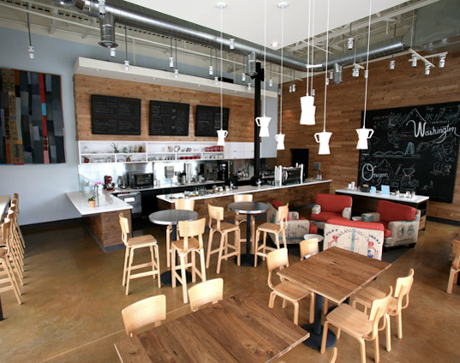It boils down to this: we simply love Houston for what it is and believe that the unique qualities of our city can merge with this passionate enthusiasm for a more eclectic culinary lifestyle. A satisfying cup or coffee or tasty sandwich served by a friendly face in a beautiful setting makes for successful experiences. We are further motivated by our enthusiasm for how local establishments can enrich the lives of Houstonians and visitors.

Proposed Location  
The location at 1018 Westheimer offers a stand-alone identity that has been a part of the Houston landscape for decades. The 1,500-square-foot building stands along a high-traffic stretch of lower Westheimer in Montrose, between the well-known north/south streets of Montrose and Waugh. This neighborhood is among the most diverse urban areas in terms of restaurants, retail and residential development within Houston.

The location of Blacksmith continues a recent trend of new and locally owned businesses along one of the busiest commercial areas of Houston inside Loop 610. Nearby personality-driven concepts such as Underbelly, The Hay Merchant, Uchi, El Real and Anvil Bar & Refuge, establish Montrose as an area of exciting new destination establishments. Retail in the area includes American Apparel, Buffalo Exchange, and numerous vintage/eclectic retail and antique shops. It is obvious that this vibrant section of lower Westheimer is showing a strong, locally driven surge in redevelopment, focusing on authentic character and distinctive identity.

Over the last several decades, many areas of Houston have seen rapid over-development as entertainment destinations. These trendy areas have neither held the attention of Houstonians, nor the market share, and thus experience short-lived success. Neighborhoods with more gradual development patterns, such as Rice Village, the Heights and lower Westheimer offer a more natural, diverse and enduring market identity that continue to draw customers over the long-term.

Parking options for Blacksmith exists behind the building itself, and are part of the purchased land, with easy access through the front or back of the shop. Approximately 25 spaces will be located on site. Through our relationships with neighborhood non-profits (churches and health care service providers), options such as 50 spaces with the Charity Guild of Catholic Women and 55 spaces on property directly to the northwest at Legacy Community Services are also available. Combined, these opportunities constitute the most convenient parking scenario for potential guests anywhere in the area. Blacksmith will draw primarily self-park patrons who would opt to park on site or along nearby streets. The hours of operation for Blacksmith will be from 7am to 5pm daily, so we feel parking will be ample.

The vehicle traffic counts during a 24-hour period, Monday-Thursday, in this area of Westheimer total 23,400 vehicles per day. With such a visually prominent location, the potential to attract daily notice among local traffic is noteworthy.

It is also important to point out that 1018 Westheimer is a unique development opportunity within a city where parking restriction has become progressively tighter over the last 3 years, and will be changing in early 2012. While Houston does not enforce zoning in the ways so many other major metropolitan areas do, Houston does use its right to maintain citywide minimum parking requirements to restrict growth in congested areas. Consequently, by taking advantage of the parking opportunities in a high-traffic area, which stands to be unable to meet city parking codes in the near future, we intend to distinguish ourselves from currently existing businesses as well as future competitors.

### Products and Services

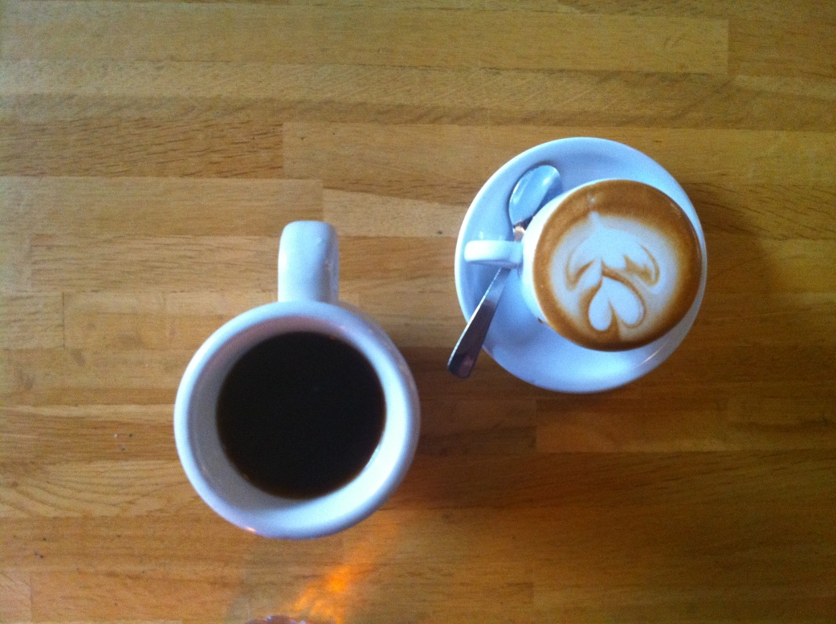Blacksmith will stand apart from other boutique coffee shops through the accessibility of our varied products. While nationally recognized coffee programs are respected and tenured for their limited menus of coffee products, the largest volume and most respected tend to cater to two distinct crowds ⎯ coffee aficionados and culinary followers. Through a menu of focused selections and high quality product, Blacksmith will capture both of these market shares. Additionally, service will be exemplary and industry leading through strict hiring standards, calibrated by the Specialty Coffee Association of America’s Barista Certification Program. All Blacksmith baristas will be required to be Level 2 certified with the Specialty Coffee Association of America’s Barista Certification Program. It is significant to note that no other facility in America currently operates with these requirements. Listed below are key points in the definition of Blacksmith as an industry leading, success-driven coffee house.

Coffee

The collaboration of Greenway Coffee Company and 1018 Real Estate Group will make the coffee offerings of Blacksmith reflect the close relationship of the two managing partners. Each group is well known for the attention to detail and careful techniques that make their products stand apart from competitors. Blacksmith’s coffee menu will consist of two sections: a simple menu of classic espresso-based drinks made from the highest quality products and a tasting menu of rare and wonderful coffees from around the world that you will only be able to enjoy at Blacksmith. Below are samples of our two menus:

Coffeehouse Menu: Tasting Menu:

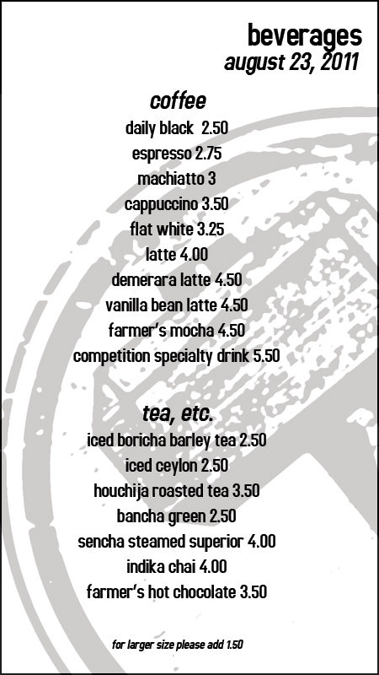 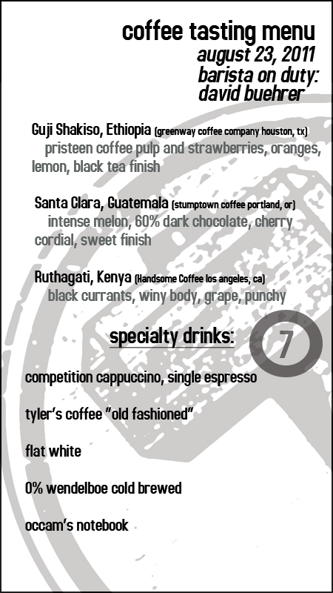

Blacksmith’s coffee program will highlight locally roasted coffee from Greenway Coffee Company as well as other prominent coffee roasters from around the United States such as Heart Coffee Roasters of Portland, Handsome Coffee Roasters in Los Angeles, and Dallis Bros. Coffee in NYC. Blacksmith will welcome each Houstonian or visitor who enters with a commercially accessible variety with a quality-focused option. Blacksmith will also offer larger cup sizes or artificial sweetening options like Splenda. By offering these options, we have the opportunity to take a customer who typically order a large latte with Splenda and convert them to a healthier, higher quality product through our product offering and staff knowledge. For this reason we will carry items that people are familiar with, as to not alienate a potential long-term customer on their first visit. Our hospitable mentality is at the heart of our business and will be the focus of Blacksmith employees. Houston is the fourth-largest city in the United States and we want to be accessible and open to as many customers as possible while maintaining a core set of quality values.

Alternate Beverages

While the core focus of Blacksmith’s beverage line will be coffee, we will also offer alternative beverage choices. To ensure we have beverage choice available for non-coffee drinkers, or those that prefer else, we will offer a few classic café drinks; chai, iced tea, hot chocolate, and various hot teas. We plan to achieve success in our alternative beverage options by utilizing our ideals with coffee and applying them to these offerings. For iced tea, two options may be available ⎯ a Korean style “Boricha” barley tea will be served and an all-natural, approachable black tea our customers will be familiar with. As far as hot teas, we will focus on offering selections from Rishi at opening, with the intent to offer stellar Japanese teas as they are made available from Greenway Coffee Company in the future. Our hot chocolate will be crafted for us by Way Back When Dairy, a wonderful Texas dairy that produces chocolate milk needing little more than steam to make a special beverage. Chai will be sourced through a friendly, nearby restaurant neighbor to Blacksmith, Indika.

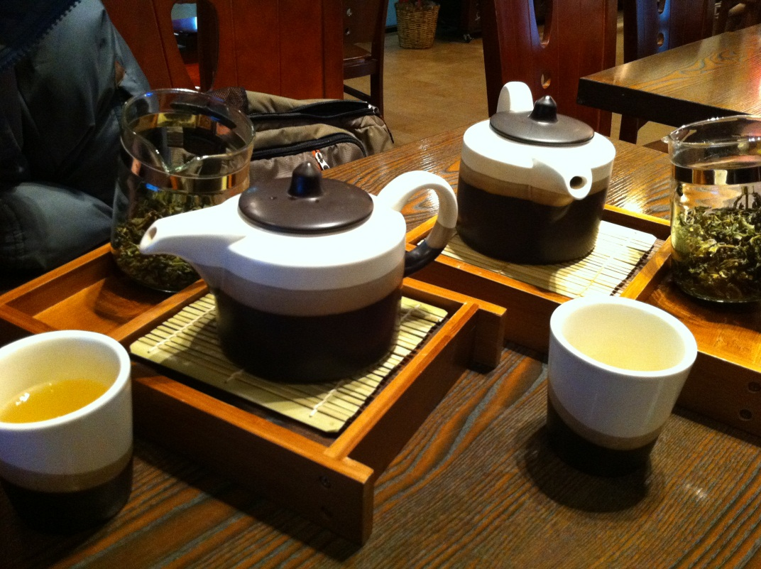

Food

While beverages will be a fundamental focus, food will not be an afterthought at Blacksmith. David Buehrer and Ecky Prabanto are well-respected food adventurers in Houston, being chronicled by some of Houston’s most influential food writers including Alison Cook of the *Houston Chronicle*. With the expectations for high quality food at Blacksmith, we plan to create a small menu of “Barista’s Choice” breakfast and lunch items. This six item menu will be inspired by the excursions David and Ecky have had at cafes across the country, including Marlow & Sons in historic Williamsburg, New York City and Cochon Butcher in New Orleans. All items will be reasonably priced at $12 and under. These choices will permanently remain on the menu, with various sides and accoutrements depending on what is at peak season and available at the farmer’s market. These three breakfast items and three lunch items will be accompanied by a chef’s menu, which will also be featured at Anvil Bar & Refuge. The chef’s menu will be more open-ended, on price point and philosophy, and will be left to the chef of Blacksmith to execute. The chef will be selected at a later date to match the opening of Blacksmith, but will be determined by the partnership. Having a working kitchen gives Blacksmith a competitive advantage over other coffee shops by increasing our average customer sale through various food options.

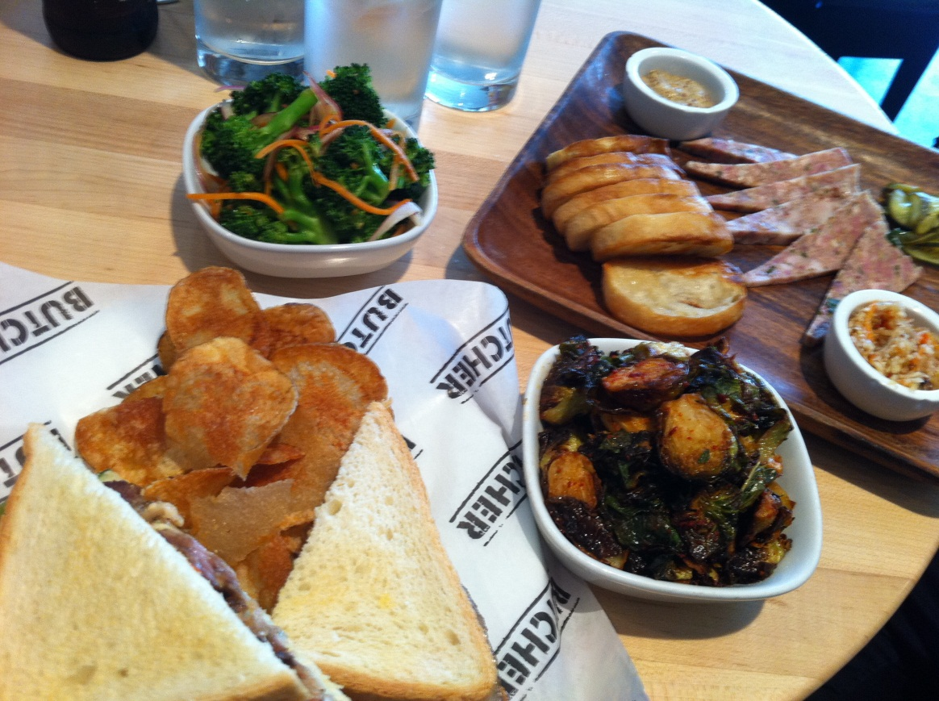

Service

Service will be the secret weapon of Blacksmith, the one last competitive advantage over all other specialty coffee retailers in Houston. Our focus on appreciating and respecting our customers will be the trademark touch to return visits and winning over customers from our competition. While other cafes are limiting the face time they have with guests buy installing obtrusive, large pieces of equipment on their bar, or having bars much too large for personal interaction to occur, Blacksmith will instead focus on utilizing bar space and equipment to interact with our customers in a way not seen in Houston. Additionally, every barista will be required to take part in a workshop provided by Greenway Coffee Company, using principles found in Danny Meyer’s service bible, “Setting the Table”. These tactics will help us understand our clientele, which is at the basis of any successful business.

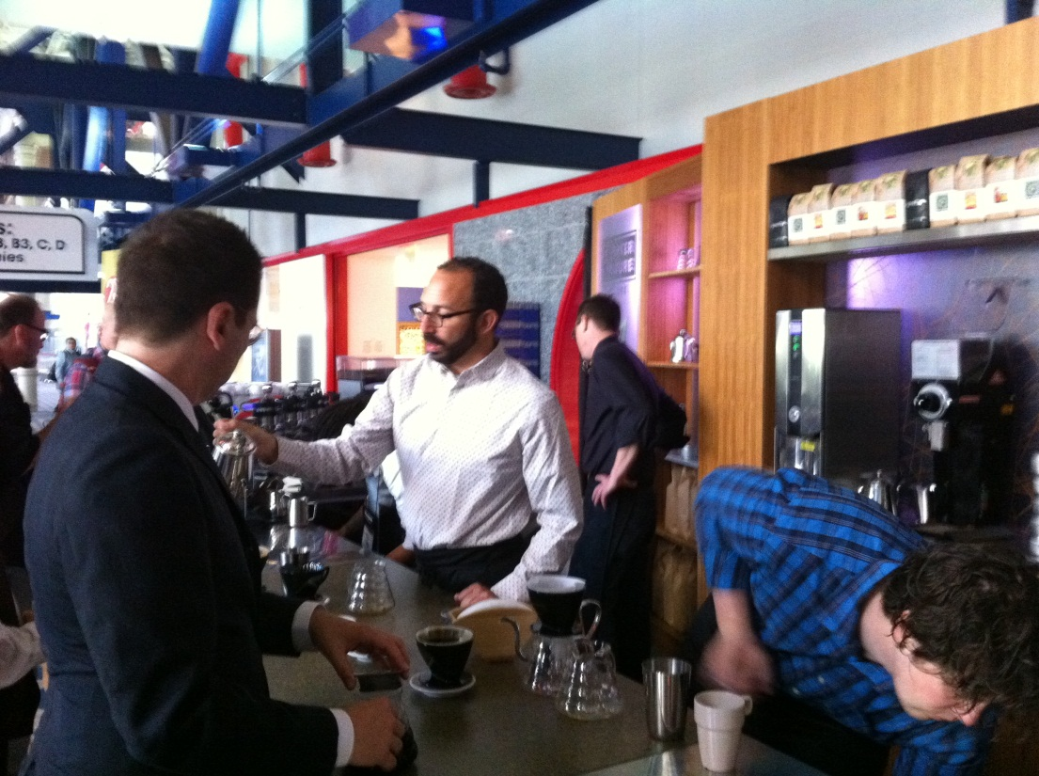

Environment and Workflow

Blacksmith’s build-out will focus on functionality, with style being emphasized by utility. The café will share some common aesthetic themes with both Underbelly and Hay Merchant to give continuity between the three projects. Collaborative Projects, the architect and builder of these projects, is making a concerted effort on creating an overall environment within our part of Westheimer and Montrose. This shared familiarity with other high profile food and beverage projects will create an immediate marking impact for the opening. Stylistically, Blacksmith will take the approach of famed restaurateur Gordon Ramsay, who once said to spend most on the quality of your product, before ever touching the building. With this in mind we will maintain a simple, clean, approachable build-out that further exemplifies the coffees and food we will be preparing.

Our workflow is divided into three sections of the bar creating a positive and efficient environment. The first section is the closed kitchen, a tight but efficient 150-square-foot space ideal for producing our focused food menu. Attached to this will be our coffee enthusiast bar ⎯ twelve bar stools designed to allow customers to sit at the bar to experience our tasting menu and barista knowledge with maximum results. With two separate espresso machines and all necessary tools, this section of Blacksmith will be designed to release the creative tendencies of the barista while at the same time allow a higher price point on limited coffees. To service customers not necessarily looking for an in-depth coffee experience, there will be a larger octagon-shaped area just to the right of the enthusiast bar to handle normal coffee volume. This gives quick-turn customers a visual appreciation of the more technique driven bar area, potentially raising intrigue and a return visit. Most customers will prefer their coffees to go and we want to service as many of these potential customers as possible, while allowing them to understand the level of service Blacksmith offers. This octagon area will house a larger espresso machine, a few more grinders, and a register and pastry case, all within reach of baristas on staff. Blacksmith’s design is to serve as many customers as possible, while still focusing on service.

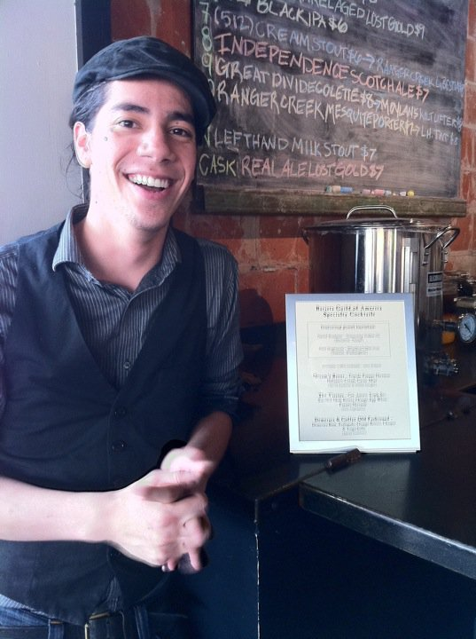Blacksmith Internship Project

At the heart of Blacksmith lies a concept unrivaled in the specialty coffee industry. This project will unite professional baristas from all over the country, all determined to find their career path in coffee. These baristas will be attracted to Blacksmith by the opportunity to instill their knowledge and craft on our local talent, while at the same time focusing on learning the aspects of the industry they want to research more in depth. This “reverse internship” will provide a program where visiting baristas commit to focusing on work and education in a rigorous series to grow professionally and build global credentials for coffee quality. They will commit to a full-time shift at Blacksmith, focus the remainder of their time on Blacksmith-provided educational material, and choosing a section of the food and beverage industry to “intern” in. These intern opportunities will be organized by David Buehrer and include green coffee importers, craft cocktail bars, pastry chef understudies, restaurant programs, coffee roasting, coffee bar management, agricultural sciences, and culinary research. These baristas will help Blacksmith create a national presence in specialty coffee and also help train the Blacksmith staff for coffee competitions, both locally and nationally. Each barista enrolled in this project will help us grow our knowledge database and create a future for specialty coffee in the global marketplace. Interaction with these visiting baristas will also be a highlight to our customers, engaging with passionate personnel from all walks of life.

### Marketing

##### Houston’s busiest and most popular food and beverage destinations are those that are capable of meeting surging demand for consistent, fresh and creative options. This balance is difficult to achieve, but with the right participants, marketing becomes rather easy because of the overwhelming demand and consequential response when a concept resonates with this market. Our history of success with establishments like Anvil, and the launching of Underbelly and Hay Merchant demonstrates an ability to provide these types of elements to guests. As such, marketing becomes a consistent part of the daily operation of Blacksmith. Developing a reputation that distinguishes a concept from the crowd, and informing media and consumers about new menus, activities, and other happenings, drive return visits and build greater media profiles.

##### In short, while marketing is obviously an enormous part of the business profile, our existing relationships, reputations, and established systems for informing the public of our concept will ensure that awareness of our establishment remains high. The toughest challenge in marketing is backing up the talk — and we have the exciting talent and personnel to do that.

##### Market Demand

Our experience as a partnership has allowed for our group to test the viability of each concept in several contexts. We are confident that a significant market demand exists for a focused coffee shop in the Montrose/Westheimer area. Typically, business plans make arguments for an existing market by discussing market demographics and general industry trends, however, it is important to note that we have been testing these concepts throughout the market for years.

Greenway Coffee Company in Greenway Plaza has garnered a local and national reputation for outstanding coffee and service despite being located in the bottom of a large business center. Additionally, special coffee events hosted by David and Ecky have consistently brought in guests in large numbers. There are numerous followers and a market demand for their unique coffee perspective and knowledge. They have been successful for years in the Houston market and garnered countless praise from media and industry professionals in that time. This pre-existing enthusiasm for this individual’s talent will again demonstrate enormous market demand for Blacksmith once David and Ecky have a showcase location in which to share their passion.

Rarely do concepts in our industry have the opportunity to prove they hold water before opening. However, the most comforting aspect of this concept is the existing demand for techniques that are already being successfully executed in the city under the supervision of our driven team. There is no question that an active and eager market awaits the opening of Blacksmith.

##### Customers

Blacksmith’s reputation and location will reach multiple demographics by offering high-quality products at approachable prices. Fortunately coffee, which has been viewed a simply a tasty wake up beverage in years past, has transcended demographics over the years with increased knowledge and improved product. Whether you are young or old, scrapping by or highly affluent, coffee is one of the more affordable “luxuries” in life, and thus allows for a very broad target market. Virtually any human above the age of 16 is a potential customer. However, in order to give context, we feel that considering the location Blacksmith’s core customer will be slightly more affluent in income ($35,000 to $85,000) and will range in age from 21 to 55.

Event Marketing

Following the proven patterns for promotions at Greenway, promotional events will be a critical part of Blacksmith’s success. Timing these activities to compensate for naturally slow periods of time through the year and then slower micro-periods of the day and week will help to generate consistent stable sales. Promotions will focus on coffee classes and other special coffee-centric events such as cuppings, roasting seminars, and events with featured guests, such as roasters and growers around the world and other coffee personalities. Further, the ever-changing coffee selection will keep customers returning.

Social & Community Engagement

Blacksmith will be an active participant in social events that are relevant to the promotion and reputations of the coffee bar. David and Ecky are already heavily vested in the SCAA, which allows them to connect with other coffee professionals around the world, giving them the unique opportunity to be able to have access to numerous products and coffee professionals. Just this past year they hosted an event at Anvil for the SCAA that brought in over 400 coffee professionals from all over the world. These types of organized events help to bring new faces into Blacksmith that might not otherwise visit and provide ongoing opportunities to attract new regular guests. Additionally, events that allow for the reputation of David and Ecky to become more publicized and popular, will also be an active part of our marketing strategy. The ongoing promotion of their personalities becomes increasingly important in promoting Blacksmith.

Social Media

Social media has changed how the service industry markets and maintains contacts with their guests. What initially began as simple e-mail lists that helped to keep consumers informed of happenings at an establishment has expanded to Facebook, Twitter, blogs, and other types of social media. Once dismissed as adolescent trivia, these tools have become a vital part of any growing business in this industry and allow for ongoing promotion to those who are actively choosing to be interested. Best of all, this type of marketing is free. Blacksmith will be an active participant in every aspect possible as frequently as possible, and with David and Ecky’s already large personal following on Twitter, as well as Blacksmith’s followers (@Bl4cksmith), we expect immediate social success.

Print & Online Media

Print and online media are anxiously awaiting the release of information about Blacksmith beyond our initial press release. The only question about print and online media will be whether the concept is positively or negatively received — which is handled through the execution of the concept.

It is worth noting that nearly every major food publication has discussed Anvil, Underbelly and Hay Merchant, including *Gourmet Magazine*, *Food and Wine Magazine*, *Saveur Magazine*, *Bon Appétit*, *Draft* and many others. We expect Blacksmith will be frequently featured by local publications such as *The Houston Chronicle*, *The Houston Press* and other online publications and blogs. All of these relationships have been cultivated over the years with the knowledge that it would be advantageous to the promoting, and continued success, of Blacksmith.

### Competitive Analysis

##### Coffee Competition

A competitive analysis of relevant businesses throughout the Houston area was conducted in order to analyze the competitive advantages and disadvantages of the Blacksmith concept. While Houston is home to many different coffee shops and cafes, two major competitive categories, area competitors and other craft coffee focused locations, emerged and were thus selected as representatives. These groups allow for standards of comparison useful in refining the concept, identifying the market niche, and projecting sales figures. The green indicates predicted success within the category and utilizes that category to the best advantage. Red indicates concern to utilize the category.

These competitors were based on proximity to blacksmith both geographical and conceptually.

Coffee Offerings (Table 1, Parts 1 and 2)

Coffee Shop 1 Coffee Shop 2   
1000 Westheimer Rd. 1000 Westheimer Rd.   
Houston, TX 77000 Houston, TX 77000

Coffee Shop 3 Coffee Shop 4  
1000 Westheimer Rd. 1000 Westheimer Rd.  
Houston, TX 77000 Houston, TX 77000

Craft Coffee Offerings (Table 2)

Craft Coffee Shop 1 Craft Coffee Shop 2 Craft Coffee Shop 3  
1000 Westheimer Rd. 1000 Westheimer Rd. 1000 Westheimer Rd.  
Houston, TX 77000 Houston, TX 77000 Houston, TX 77000

Table 1: Competitive Analysis – Coffee Offerings: Part 1

|  | Our Key Strength | Our Key Weakness | Blacksmith | Coffee Shop 1 | Coffee Shop 2 |
| --- | --- | --- | --- | --- | --- |
| Product |  |  | Able to offer unique product due to vertical integration with Greenway Roasting Company. | Offers standard, run of the mill product indifferent from other concepts. | Offers standard, run of the mill product indifferent from other concepts. |
| Quality |  |  | Highest standards for quality through equipment, operations and baristas are key characteristics for concept. | Lack equipment, system controls and staff experience. | Use local product, but lack understanding of current coffee trends. |
| Selection |  |  | Diverse selection of quality coffee only found at Blacksmith. Diverse food options. | Standard coffee selection, with focus on flavoring additions to enhance taste. | Limited selection of coffee, but diverse selection of food. |
| Service |  |  | Knowledgeable staff focused on quality product and the guest experience. | Friendly staff, but lack product knowledge. | Friendly staff, but lack product knowledge. |
| Reliability |  |  | Location, although well-know, is new for this concept. Operators are well established nationally. | Consistent level or service in an established location. | E Consistent level or service in an established location. |
| Stability |  |  | Strong concept, dedicated leaders, with history of success and forward thinking. | Long-standing history in current location. | Long-standing history in current location. |
| Expertise |  |  | Owners and staff widely considered experts and influencers of their industry. | Low to medium level of expertise. | Lack proper training and product knowledge. |
| Company Reputation |  |  | Company and staff have high reputation in Houston and nationally. | Established business and location, but not known for product. | Slightly better than average reputation for product. |
| Location |  |  | Premier location in key Houston area, which includes ample parking. | Large square footage on major street but with limited parking. | Good location on high traffic corner with very limited parking. |
| Appearance |  |  | Careful and professional thought will be given to exterior and interior design. Inviting nostalgic retro fit to older structure. | Older design, with no updates in many years. Known for patio seating if weather is appropriate. | One of the few authentic buildings with visually appealing exterior, but lacking interior cohesion. |
| Advertising |  |  | Will instantly gain local media attention, and large network of national contacts will garner wider audience. Use of social media will drive continued awareness. | Website and some social media. Local advertising in print. | Website and some social media. Local advertising in print. |

Table 1: Competitive Analysis – Coffee Offerings: Part 2

|  | Our Key Strength | Our Key Weakness | Our  Concept | Coffee Shop 3 | Coffee Shop 4 |
| --- | --- | --- | --- | --- | --- |
| Products |  |  | Able to offer unique product due to vertical integration with Greenway Roasting Company | Offers a low quality product that has maintained sales based on location. | Offers standard, run of the mill product indifferent from other concepts. |
| Quality |  |  | Highest standards for quality through equipment, operations and baristas are key characteristics for concept | Provides illusion of quality coffee, but fails to deliver reality | Use local product, but lack understanding of current coffee trends |
| Selection |  |  | Diverse selection of quality coffee only found at Blacksmith. Diverse food options. | Limited in both quality coffee and food selection. | Limited in both quality coffee and food selection. |
| Service |  |  | Knowledgeable staff focused on quality product and the guest experience. | Adequate service but lacks product knowledge. | Adequate service but lacks product knowledge. |
| Reliability |  |  | Location, although well-know, is new for this concept. Operators are well established nationally. | Has proven unreliable in recent months after management changes. | Consistent level or service in an established location. |
| Stability |  |  | Strong concept, dedicated leaders, with history of success and forward thinking. | Long-standing history in current location. | Long-standing history in current location. |
| Expertise |  |  | Owners and staff widely considered experts and influencers of their industry. | Despite attempts to train, high turnover results in lack of experience. | Low level of expertise. |
| Company Reputation |  |  | Company and staff have high reputation in Houston and nationally. | Known as an art school food court. | Known as a social location more than a coffee or food location. |
| Location |  |  | Premier location in key Houston area, which includes ample parking. | High foot traffic location, however out of core demographic. | Large square footage on major street with little parking. |
| Appearance |  |  | Careful and professional thought will be given to exterior and interior design. Inviting nostalgic retro fit to older structure. | Interesting art driven building and design. | Missed opportunity to improve on design and appearance after fire in 2010. |
| Advertising |  |  | Will instantly gain local media attention, and large network of national contacts will garner wider audience. Use of social media will drive continued awareness. | Uses advertising with little or no effect. | Website and some social media. Local advertising in print. |

Table 2: Competitive Analysis – Craft Coffee Offerings

|  | Our Key Strength | Our Key Weakness | Blacksmith | Craft Coffee Shop 1 | Craft Coffee Shop 2 | Craft Coffee Shop 3 |
| --- | --- | --- | --- | --- | --- | --- |
| Product |  |  | Able to offer unique product due to vertical integration with Greenway Roasting Company. | Offers unique product through vertical integration with own roasting company. Technical skill of roaster leads to inconsistent product. | Offers Greenway Roasting Company coffee in a café setting with quality food. | Offers Greenway Roasting Company coffee as well as other roasters. Product can be inconsistent due to poor roasting companies and lack of staff training. |
| Quality |  |  | Highest standards for quality through equipment, operations and baristas are key characteristics for concept. | Well-trained staff, but lack of supervision leads to inconsistent execution. | Use local product, but lack understanding of current coffee trends. | Lacks consistent training and supervision to maintain quality. |
| Selection |  |  | Diverse selection of quality coffee only found at Blacksmith. Diverse food options. | Uses only their roasted product, which leads to limited selection for customer base. | Limited selection of coffee, but diverse selection of food. | Diverse selection of both coffee and food. |
| Service |  |  | Knowledgeable staff focused on quality product and the guest experience. | Satisfactory staff with some knowledge, but little customer interaction. | Friendly staff and service, but lack product knowledge. | Friendly staff and service, with good knowledge and varied product. |
| Reliability |  |  | Location, although well-know, is new for this concept. Operators are well established nationally. | Consistent level or service in an established location. | Consistent level or service in an established location. | Consistent level or service in an established location. |
| Stability |  |  | Strong concept, dedicated leaders, with history of success and forward-thinking. | Long-standing history in current location. | Long-standing history in current location. | Recent history proving to be stable long-term. |
| Expertise |  |  | Owners and staff widely considered experts and influencers of their industry. | Low to medium level of expertise. | Low to medium level of expertise. | Low to medium level of expertise. |
| Company Reputation |  |  | Company and staff have high reputation in Houston and nationally. | Company and staff have high reputation in Houston. | Slightly better than average reputation for product. | Company and staff have high reputation in Houston. |
| Location |  |  | Premier location in key Houston area, which includes ample parking. | Small square footage on major street with limited parking. | Medium square footage on major street with ample parking. | Large square footage on major street with ample parking. |
| Appearance |  |  | Careful and professional thought will be given to exterior and interior design. Inviting nostalgic retro fit to older structure. | Well thought out floor plan with some effort given to aesthetic qualities. | Aesthetics feel dated and lack a conceptual drive. | Well thought out strategy in both aesthetic and operational elements. |
| Advertising |  |  | Will instantly gain local media attention, and large network of national contacts will garner wider audience. Use of social media will drive continued awareness. | Website and some social media. Local advertising in print. | Website and some social media. Local advertising in print. | Website and some social media. Local advertising in print. |

In short, our concept offers a superior and distinct product that cannot be found at any other establishment nearby. The expertise offered by our concept will become the most noteworthy coffee destination in the city. However, our popularity could limit interaction and service capabilities if not controlled. Fortunately, our experience in similar situations will allow us to adequately train and manage this potential obstacle.

### Financial Plan

Our financial plan is carefully calculated and based on extensive research into cost estimates provided by outside professionals and our own operations experience. We feel strongly that the majority of this financial plan is an accurate estimate of our concept’s potential.

Opening Budget  
All efforts have been made to create a start-up budget that utilizes funds in an effective and intelligent manner, while providing an alluring environment for guests and an efficient workspace for employees. Reducing initial costs without compromising business success is vital to making any concept profitable. Our initial proposal requires a total of $388,556. This startup fund will be allocated to two categories: building renovations and operating infrastructure.

|  |  |
| --- | --- |
| Building Renovations | $235,280 |
| Operating Infrastructure | $153,276 |
| Opening Budget Total | $388,556 |

*Building Renovations*Renovations of the property will be handled by Houston’s restaurant design and contracting firm, Collaborative Projects. Jim and Noah Herd’s experience in redeveloping properties for restaurant and bar use is unmatched. Their work on restaurants such as Haven, Ibiza, Underbelly and The Hay Merchant indicate a superior understanding of both the guest and operator perspective. Collaborative Projects will oversee all elements of the construction process, especially those relevant to city codes including kitchen layout and equipment installation.

Additionally, Collaborative Projects’ willingness to work with us on this concept on the heels of Underbelly and The Hay Merchant suggests a vested interest in the success of the project as an on-going way to build their reputation and brand. The projected value of the renovations through this contractor is $235,280. We estimate a build-out period of between three and six months following completion of the permitting process assuming no unforeseen problems.

*Operating Infrastructure*A calculated budget has been established for expenses outside of the building renovations required for operations. This Operating Structure Budget essentially includes everything that is crucial to turning a renovated property into a successful coffee location (operating funds, equipment, POS system, etc.). These estimates were based on prior experiences, and we feel are as accurately developed as possible.

Operating Infrastructure

|  |  |
| --- | --- |
| Rent (7 months) | $14.857 |
| Equipment | $57,099 |
| Stock / Inventory | $5,000 |
| Entertainment | $4,000 |
| POS System | $13,800 |
| Administration | $5,000 |
| Public Relations | $6,500 |
| Opening Labor & Training | $8,502 |
| Permitting | $6,500 |
| Insurance (1 Year) | $17,000 |
| Legal | $3,000 |
| Accounting | $2,000 |
| Opening Security Funds | $10,000 |
| Operating Structure Budget Total | $153,276.00 |

Operational Budget  
This operating segment of our budget is based on sales projections which we expect to be stable throughout the concept. In the event that sales increase beyond this point, operational expenses will coincide; however, sales beyond this point will have a higher profit percentage.

|  |  |  |  |
| --- | --- | --- | --- |
| Year 1 Operational Budget | Weekly | Monthly | Yearly |
| Utilities | $346.15 | $1,500 | $18,000 |
|  |  |  |  |
| Rent | $490.38 | $2,125.00 | $25,500.00 |
|  |  |  |  |
| Stock / Inventory Total | $2,927.55 | $12,686.04 | $152,232.53 |
| Coffee | $811.75 | $3,517.56 | $42,210.78 |
| Retail Coffee & Beverages | $1,021.73 | $4,427.48 | $53,129.81 |
| Food | $836.38 | $3,624.33 | $43,491.94 |
| Cleaning Supplies & Services | $200.00 | $866.67 | $10,400.00 |
| Bar / Admin. Supplies | $57.69 | $250.00 | $3,000.00 |
|  |  |  |  |
| Labor Total | $3,225.62 | $13,977.66 | $167,732.00 |
| Overall Labor | $3,200.62 | $13,869.33 | $166,432.00 |
| Payroll Admin. Cost ($50 Bi-Weekly) | $25.00 | $108.33 | $1,300.00 |
|  |  |  |  |
| Taxes Total | $1,406.32 | $6,094.06 | $73,128.67 |
| Payroll Tax | $181.19 | $785.15 | $9,421.75 |
| Payroll Tax on Tip Income | $128.69 | $557.67 | $6,692.01 |
| Sales Taxes | $952.21 | $4,126.24 | $49,514.90 |
| Accounting | $144.23 | $625.00 | $7,500.00 |
|  |  |  |  |
| Miscellaneous Total | $532.80 | $2,308.79 | $27,705.44 |
| Liability Insurance | $153.85 | $666.67 | $8,000.00 |
| Workers Comp Insurance  (3.41% of Wages/Tips) | $61.59 | $266.89 | $3,202.73 |
| Repair & Maintenance | $144.23 | $625.00 | $7,500.00 |
| Credit Card Transaction Fees (1.5% of Sales) | $173.13 | $750.23 | $9,002.71 |
|  |  |  |  |
| Total Operating Cost Expenditures | $8,903.82 | $38,583.22 | $462,998.64 |

We believe that these numbers would express a normal operating scenario. Our staff, management, and ownership are very capable of achieving numbers better than these, but in the event that unforeseen challenges impacted the project, we feel that these numbers reflect this type of situation. In several categories, we feel that our estimates are high and will be reflected in additional profits at the end of the year. Under this model, after all costs are subtracted, a profit percentage of 22.86% is obtained.Sales Forecast  
The sales forecast for Blacksmith is based on significant analysis of our past experience, the market niche, and competitor sales figures. Based on the established operations budgets and these analyses, we were able to correspondingly create projections and tangible sales goals for the concept.

|  |  |
| --- | --- |
| BLACKSMITH TOTAL SALES |  |
| Monthly Average Totals | $50,015.05 |
| Weekly Average Totals | $11,412.17 |
| Daily Average Totals | $1,630.31 |
| ANNUAL GROSS INCOME | $600,180.63 |

Combining this sales scenario with the operating budget profit percentage of 22.86%, an annual profit projection of $137,201.29 is obtained. Assuming a ten years of operation following construction, the concept would then generate $1,372,012.90 in net profit. Again, we believe that we can accomplish more under ideal circumstances, but we prefer to over-deliver.

Investor Profitability  
In order to raise the funds necessary to open the concept, we developed an extremely rewarding program for investors.

Rapid investor repayment of equity is of primary concern, and initially 100% of all profits will go directly to investors until their initial investment has been returned. Additionally, investors will receive 12% annual return on their equity investment. Our complete devotion of all initial profits to our investors as a means to quickly return their funds is almost unheard of in privatized restaurant funding. Based on projected sales numbers, we would return the equivalent of our investors’ initial investments approximately 2.83 years after opening.

Following the return of equity and interest payments, a post-equity scenario will be implemented in which 40% of all profits will be distributed to investors based on their individual contributions. There will be three years of this dividend structure. At the end of the previous three-year period, payments to investors would transition to 30% of all profits for three more years. At the end of this period, the investors will receive a payment of 10% for an additional four years. This means that a $25,000 investment stands to yield the following repayments our projected model:

|  |  |  |  |
| --- | --- | --- | --- |
| 3.42 Year Preferred Return Period | | | $30,989.36 |
| Period I, II, III Post-Equity Periods | |  | | |
| Year 1 (PI) | $3,530.56 | ($100,000 Share of 40% Investor Payment) | | |
| Year 2 (PI) | $3,530.56 | ($100,000 Share of 40% Investor Payment) | | |
| Year 3 (PI) | $3,530.56 | ($100,000 Share of 40% Investor Payment) | | |
| Year 1 (PII) | $2,647.92 | ($100,000 Share of 30% Investor Payment) | | |
| Year 2 (PII) | $2,647.92 | ($100,000 Share of 30% Investor Payment) | | |
| Year 3 (PII) | $2,647.92 | ($100,000 Share of 30% Investor Payment) | | |
| Year 1 (PIII) | $882.64 | ($100,000 Share of 10% Investor Payment) | | |
| Year 2 (PIII) | $882.64 | ($100,000 Share of 10% Investor Payment) | | |
| Year 3 (PIII) | $882.64 | ($100,000 Share of 10% Investor Payment) | | |
| Year 4 (PIII) | $882.64 | ($100,000 Share of 10% Investor Payment) | | |
| Preferred Return Period + 10 Year of Operations | $53,055.35 | (212.22% of Initial Investment) | | |

This payment structure rewards our investors for their participation in an unconventional investment. We feel strongly that this structure is fair and competitive. An investment in our concept is an investment that reflects an understanding of current market demands and the ability of qualified professionals.